3D Printer Project Log

4/20/19

Initial commint of PROJ0001 to git. Push to github. Look into Visual Studios code(editor) for git.
- To set a command alias, use e.g. alias p='python'. Save to ~/.bashrc file to make it permanent. Reload bashrc file with source ~/.bashrc

4/14/19:
Installing pip , a package manager for python:
- https://linuxize.com/post/how-to-install-pip-on-ubuntu-18.04/#installing-pip-for-python-2
Uninstalling current pyserial and installing pyserial 2.5
- type:
sudo pip uninstall pyserial
sudo pip install "pyserial==2.5”

3/30/19
Suedo code:
#open ports and check statuses
pc: pc – open /dev/ttyUSB0, baud 115200
pc: pc – open /dev/ttyACM0, baud 9600
pc: marlin – report status
marlin: pc – ready
pc: arduino – report status
arduino: pc – ready
#collect coordinates
pc: pc – open 'coordinates' file for writing
pc: marlin – home
marlin: pc – ok
pc: marlin – move 1mm
marlin: pc – ok
pc: marlin – report position
marlin: pc – position is x
marlin: pc – ok
pc: pc – store x as xVal

pc: arduino: read light
arduino: pc – light val is y
arduino: pc – ok
pc: pc store y as yVal

pc: pc – write xVal and yVal to end of 'coordinates' file.

3/29/19
- pySerial documentation: https://pythonhosted.org/pyserial/
- setup:
  - import serial
  - ser = serial.Serial('/dev/ttyUSB0',115200, timeout = 1)
- reading into file with pySerial: https://stackoverflow.com/questions/19865137/how-to-export-pyserial-reading-data-into-text-file-or-matlab
- Baseline the connection(assuming unit just powered on):
  - ser = serial.Serial('/dev/ttyUSB0', 115200, timeout=0, parity=serial.PARITY_EVEN, rtscts=1)
  - s = ser.read(1000)
  - print(s)

- How to send file of Gcode:
  - f = open('/home/user-1/newPosition.txt', 'r')
  - contents = f.read()
  - ser.write(contents)
- How to execute .py file (from cmd and within interpreter); https://stackoverflow.com/questions/1027714/how-to-execute-a-file-within-the-python-interpreter

3/26/19
- How to setup minicom:
https://help.ubuntu.com/community/Minicom
- How to find which ttyUSBX is connected:
dmesg | grep tty
- Setting up Serial Port Communication:
https://unix.stackexchange.com/questions/22545/how-to-connect-to-a-serial-port-as- simple-as-using-ssh

Output(before setup minicom) of: -a
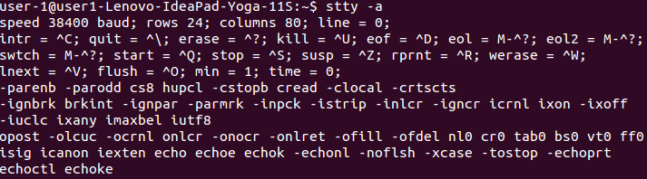
Output(before setup minicom) of: stty < /dev/ttyUSB0
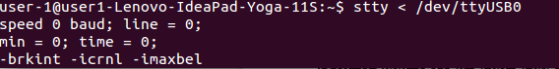
Minicom port default settings:
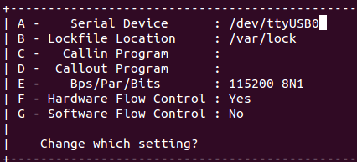
Output(after setup minicom) of: stty < /dev/ttyUSB0 -a
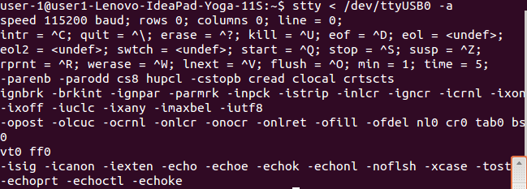
Output of Minicom after sending M115 command in text file:
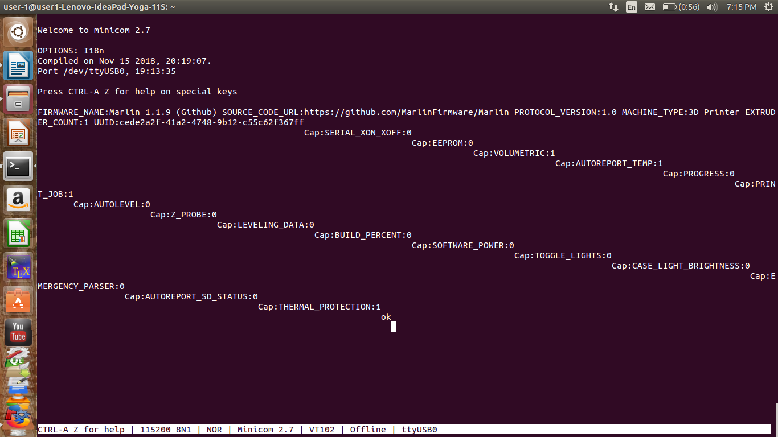
- I changes settings for line wrap, line feed, and carriage return to 'YES'. Otherwise the output was tabbed all strange.
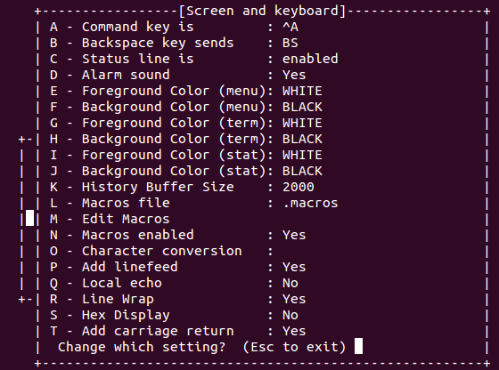

3/24/19
Having under extrusion issues. The PTFEtube needs to go all the way down through the heat sink and press flush against the hot end. The bowden tube coupler at the top of the heat sink has a known issue of releasing tension on the bowden tube and creating a gap between the tube and the hot end, where filament gets melted and deformed causing a blockage.
Tube gap explanation:
https://www.youtube.com/watch?v=-vH_spN5wyw
How to fix tube gap on Creality:
https://www.youtube.com/watch?v=30qqKUwviww
Where to buy new bowden coupler:
https://www.amazon.com/dp/B07DC594D6/ref=as_li_ss_tl?psc=1&pd_rd_i=B07DC594D6&pd_rd_w=kZbMD&pf_rd_p=f0dedbe2-13c8-4136-a746-4398ed93cf0f&pd_rd_wg=sJZE0&pf_rd_r=Y9T6QZM0PTFAJYDQZ5GY&pd_rd_r=ad718cd7-03b3-11e9-ba5f-4d00cf6be912&linkCode=sl1&tag=fatdragongame-20&linkId=93d861a2e391332c54ed640c051d9dcc&language=en_US
Creality Hot End kit:
https://www.amazon.com/Creality-Original-Extruder-Assembled-3D/dp/B07CKQRT89/ref=sr_1_6?crid=1X8TBL7L1COFR&keywords=creality+cr-10+hot+end&qid=1553439382&s=industrial&sprefix=creality+cr-10+%2Cindustrial%2C139&sr=1-6
Hot end cover:
https://www.amazon.com/HWA-KUNG-Silicone-Extruder-Creality/dp/B07KWWZZWC/ref=sr_1_fkmrnull_2?keywords=creality+cr-10+hot+end+cover&qid=1553439582&s=industrial&sr=1-2-fkmrnull
How to change nozzle Creality CR-10:
https://www.youtube.com/watch?v=FRzsGttNMyk

3/23/19
How to to send and receive commands over serial port?
1. Use Host software like Printrun/Printcore: https://github.com/kliment/Printrun/tree/master#running-from-source
2. https://3dprinting.stackexchange.com/questions/5382/issues-with-direct-g-code-transmission-via-serial-port
3. https://3dprinting.stackexchange.com/questions/3112/how-to-directly-send-g-code-to-printer-from-a-linux-terminal
4. https://unix.stackexchange.com/questions/327188/how-to-monitor-a-serial-connection-250000-baud/327366#327366

Unable to send command over Serial Port to Marlin firmware. Either it does not respond back or it responds with “unknown command” in a never ending loop. My baud rate is set to 115200 in linux. Baud rate is 115200 in configuration.h of Marlin. Seems to be a baud issue though.
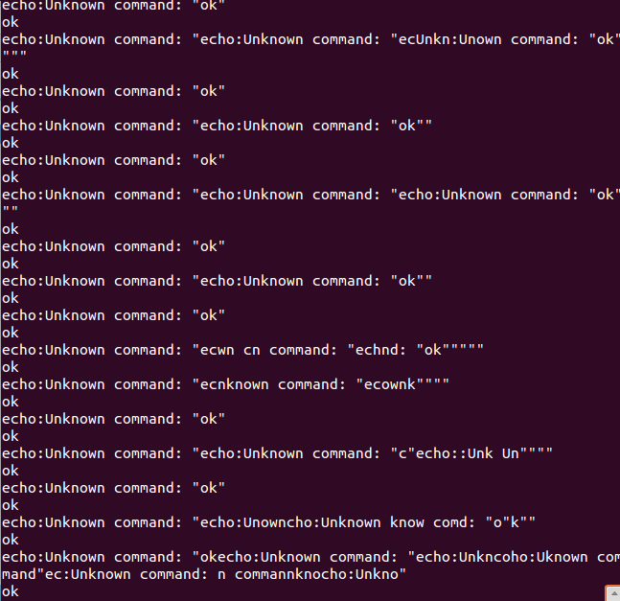
How to check information about specific Serial Port : stty < /dev/ttyUSB1

3/17/19:

The creality CR10 mainboard V1.1.4 does not have a USB/VREG jumper. Can I use USB power anyway?
The AVRISPMKII has flashing orange light when connected to ISP header on main board. There could be a couple of reasons for this:
- issue with reset line
- no pullup resistor on reset line. There needs to be 5V on reset line during reset. 10K Pullup resistor? Cannot be smaller than 5K. Try connecting 10kom resistor between 5v and reset. https://www.microchip.com/webdoc/avrispmkii/avrispmkii.hardware_resetline.html
https://www.google.com/search?client=ubuntu&channel=fs&q=how+install+pullup+resisitor&ie=utf-8&oe=utf-8#kpvalbx=1
- Blinked orange LED fixed. The voltage on reset was a ~4.5V because the vcc was also at 4.5V. Not enough power supplied from USB from computer. Connected USB from Duracell and voltage on Vcc and Reset pins raised to ~4.79V. Solid green light appeared!
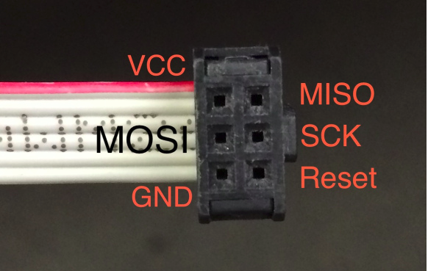Illustration 1: AVRISPMKII Pinout

How To Wire AC Line Power to a 3D Printer Kit Power Supply
https://www.youtube.com/watch?v=Bqar4cuVF_A

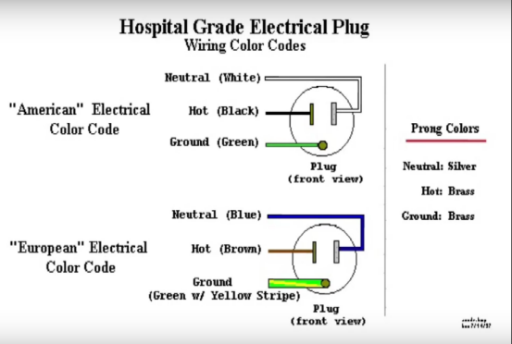Illustration 2: Electrical Plug Pinout

2/24/19:

CR-10 Main Board Programming: https://www.youtube.com/watch?v=7J7NYnxL5vA

https://www.thingiverse.com/thing:1099705

Creality cr-7 imechanical design is called Ormerod. Can buy parts kit?

2/18/19:

1. trying latest Marlin Firmware 1.19
2. Use example config files of Creality CR-8. Changed motherboard to Melzi
3. download Arduino 1.6.8
4. configuration.h changes:
#define HEATER_0_MAXTEMP 260
#define MOTHERBOARD BOARD_MELZI_MAKR3D
#define DEFAULT_AXIS_STEPS_PER_UNIT { 80, 80, 400, 92.60 }
#define DEFAULT_MAX_FEEDRATE { 500, 500, 5, 25 }
#define DEFAULT_MAX_ACCELERATION { 500, 500, 100, 5000 }
#define DEFAULT_ACCELERATION 500
#define DEFAULT_RETRACT_ACCELERATION 500
#define DEFAULT_TRAVEL_ACCELERATION 500
#define X_BED_SIZE 100
#define Y_BED_SIZE 100
#define ENDSTOPPULLUP_XMIN
#define ENDSTOPPULLUP_YMIN
#define ENDSTOPPULLUP_ZMIN
x-endstop not triggering, lways ashows as “L”, possible solutions:

1. Fresh install of Arduino 1.0.6. Does not come with Sanguino out of box, need to add.
2. Downloaded Sanguino-0101r1.zip from here: https://code.google.com/archive/p/sanguino/downloads
per instructions of forum here: https://reprap.org/forum/read.php?158,486938
- Do I need? “...If you are putting you own bootloader on the chip you will need to edit the boards.txt file and set the fuses you want as the default leaves the jtag enabled wich stops all endstops and x direction lines working...”???
3. Unzipped “Sanguino” tar ball and added it to arduino 1.0.6 folder, to achieve the following directory tree:
/home/user-1/arduino-1.0.6/hardware/sanguino/
boards.txt
bootloaders/
cores/
firmwares/
programmers.txt
variants/
4. programmed bootloader onto Melzi board with AVRISP MKII.
5. programmed blink test onto melzi with USB cable.
6. #define AXES_MAX_LENGTHS {50, 50, 50}
#define X_HOME_DIR -1
7. uploaded marlin.ino firmware. X-axis control works. The endstop does not quite seem to work.
. Put Sanguino and marlin firmware files into /home/user-1/Projects/PROJ-0001

I am currently using Arduino 1.8.7 with sanguino libraries added. Will try uninstalling and completely and using older version of arduino. Arduino files are found in 3 locations: The installation folder, the sketchbook folder, and the Arduino15 folder. The installation folder should be removed when you uninstall but the other two folders remain so you will need to remove those also to get a completely clean install. Prior to uninstall:
-Sketchbook location: /home/user-1/Arduino
-Additional boards manager: https://adafruit.github.io/arduino-board-index/package_adafruit_index.json
- /home/user-1/.arduino15

Common 3d Printer DIY is to use Arduino Mega 2560 with Ramps
I set in configuration.h:
Mendel2
#define AXES_MAX_LENGTHS {100, 100, 100}
#define INVERT_X_DIR false // for Mendel set to false, for Orca set to true

#define X_HOME_DIR 1

2/16/19:

Powered on Printer for first time and tried to drive motors manually with Octoprint host. Motors made a light buzzing but did not turn. I tried setting both #define SERIAL_R 4700 and
#define SERIAL_R 10000 but no difference noted.
Things to try:
-older Arduino version
-older Marlin version (v1 vs v2?) I have version “1.0.2 RRP”
-setting motor parameters (steps, accelerationm etc. Prusa calculator site)
- endstops
- home the motors first, only go one direction until endstop triggered.
- baud rate

2/12/19:

I successfully programmed Marlin onto the Melzi board. I left
most parameters as the default values. I made the following changes the configuration.h file:

Configuration.h file

Uncommented “#define REPRAPPRO_MENDEL” //Legacy Mendel
Uncommented “#define REPRAPPRO_MELZI”
Uncommented “#define SERIAL_R 10000”

replace “fpos_t” with “filepos_t” everywhere in sketch.

2/7/19:

When flashing bootloader, be careful with AVRISP mkII is selected as programmer. Arduino IDE lists two. The topmost one works. The bottom most one throws error.

I have successfully programmed a blink sketch to to my Melzi board.

I am unable to upload the sketch while the Melzi is connected to the computer with a micro USB connector alone, and using the Arduino “upload” button. Does the USB connector need to be a printer type USB cable?
I can successfully upload a sketch using the AVRISP MKII programmer. I need to give permissions to the AVRISP MKII every time it is plugged into the computer:
Upload sketch using SKETCH-->Upload Using Programmer button.
'lsusb' to find the bus and device numbers
'sudo chmod 666 /dev/bus/usb/002/044' (ex: bus 002 device 044)
'ls -al /dev/bus/usb/002/044' to ensure read/write privileges

Marlin Firmwarwe clone:
~/Documents/CAD/Firmware/Marlin-master/Marlin

Arduino Source:
/home/user-1/Documents/arduino-1.8.7/hardware/arduino/avr/cores/arduino

Configuration.h file
Uncommented “#define REPRAPPRO_MENDEL” //Legacy Mendel
Uncommented
Uncommented #define SERIAL_R 10000

ERRORS/ISSUES

1. Time Out

Using Port : /dev/ttyUSB4
Using Programmer : stk500
Overriding Baud Rate : 57600
avrdude: stk500v2_ReceiveMessage(): timeout

ISSUE: Do not use “Upload” button. Causes timeout, reason unknown. Go to Sketch-->Upload using programmer.

2. Ser_Open()

avrdude: ser_open(): can't set attributes for device "/dev/ttyS0": Inappropriate ioctl for device

avrdude done. Thank you.

Error while burning bootloader.

ISSUE: Wrong AVRISP mkII selected in Arduino IDE while burning bootloader. Two “Identical” options are given in list, but only the top one works correctly. Bottom one throws error.

3. Missing program.tool

Error while uploading: missing 'program.tool' configuration parameter

ISSUE:Wrong AVRISP mkII selected in Arduino IDE while uploading sketch. Two “Identical” options are given in list, but only the top one works correctly. Bottom one throws error.

4. Permission Denied

avrdude: usbdev_open(): cannot open device: Permission denied
avrdude: usbdev_open(): did not find any USB device "usb" (0x03eb:0x2104)

ISSUE: Need read/write permissions for device/programmer in Linux.

5. Blinking Orange light on AVRISP MKII
when connected to ISP header on Melzi board, the status light on MKII wass blinking orange.
ISSUE: voltage on Reset pin was too low, ~4.5V. Increased voltage to ~4.79 by using USB power from Duracell charger. Status light turned green

6. Under Extrusion

Having under extrusion issues. The PTFEtube needs to go all the way down through the heat sink and press flush against the hot end. The bowden tube coupler at the top of the heat sink has a known issue of releasing tension on the bowden tube and creating a gap between the tube and the hot end, where filament gets melted and deformed causing a blockage.
Tube gap explanation:
https://www.youtube.com/watch?v=-vH_spN5wyw

Underextrusion top reasons:
https://www.youtube.com/watch?v=V7fxY62gTkw

How to fix tube gap on Creality:
https://www.youtube.com/watch?v=30qqKUwviww
7. No response from Marlin, Arduino Serial Monitor
Sending command M115 or M119 to Marlin from Arduino serial monitor does nothing. No response heard back.
ISSUE: I was not sending the carriage return command to signify end of line. Change the “No line ending” to “Carriage return” at the bottom of the serial monitor window.

8. python readline() unable to detect 'ok' from file Marlin and arduino message files
I stored the output of the serial comms from Marlin and Arduino into a file. Using python readline() could not detect 'ok' string from either device
ISSUE: Marlin send strings with line termination, so python needs to look for 'ok\n' string. Arduino's serial.println() function send strings with line termination and carriage return, so python needs to look for 'ok\r\n' string. Note the order of \r\n has to be exact, \n\r will not work.

9. Aduino Serial.read() misreporting numbers
Serial.read() interperats integer value 1 as 45.
ISSUE: Serial.read() reads values on the comms as ASCII, and so will report the ASCII value instead of the integer value. The solution is to send value as type binary over the comms. In python this can be accomplished with the pySerial Struct function (e.g: ardSer.write(struct.pack('<B', 1)) to write integer = 1 to arduino.

10. Unable to receive message from Arduino over serial port.
PySerial was unable to receive message from Arduino over the serial port. However, the Arduino serial monitor was able to see the messages being sent from Arduino to pySerial.
ISSUE: the Arduino serial monitor was consuming the message, before pySerial could read it. The solution was to close the arduino serial monitor. It cannot be open at the same time or else it reads and empties the comms buffer?

11. Unable to read file immediately after writing to it, python
ISSUE: after writing to the file, the cursor is at the end. Need to reset cursor to beginning of file using filename.seek(0) after writing. Then we can read.

12. Pyserial reads gibberish from Marlin after serial port closed and reopened
The first time that a serial port is opened I am able to communicate with marlin OK. After closing and reopening the serial port, I get gibberish hex values that seem to indicate a baud issue. Changing the bit parity of the port seems to fix the issue, until the port is closed again.

ISSUE: Bug in Pyserial 2.7 and 3.* where the port is not being configured correctly when it is reopened. Specifically, in the file “serialposix.py”, the _reconfigurePort only calls termios.tcsetattr when the settings have changed. The solution is to downgrade to python 2.5
https://raspberrypi.stackexchange.com/questions/37892/raspberry-pi-and-serial-only-working-one-shot
https://github.com/pyserial/pyserial/issues/26
https://raspberrypi.stackexchange.com/questions/37892/raspberry-pi-and-serial-only-working-one-shot
https://github.com/pyserial/pyserial/commit/94284703d760787a627ec48fa6d8fdc1ee6ab0d9

